INTELLECTUAL PROPERTY PROTECTION TECHNIQUES FOR DIGITAL CARTOGRAPHIC DATA ADAPTED FROM CARTOGRAPHIC COPYRIGHT TRAPS USED ON PRINTED MAPS

Matthew T. Rice
NCGIA Postdoctoral Fellow, UCSB Department of Geography, Santa Barbara, CA, USA
rice@geog.ucsb.edu

For millennia, knowledge about the Earth has been organized, presented, and described through maps. The verbal, textual, and graphical information used in creating maps has always been a valuable commodity. Many approaches for protecting the intellectual property of maps have developed as a direct outgrowth of marketing and commerce opportunities, particularly during the exploration and colonization of distant lands by European powers. This research project explores that history, with an emphasis on ways that artificial embedded artifacts — cartographic traps — have been used on paper maps as a means of identification and intellectual property control. Cartographic traps are effective because they are very hard to detect and remove, and have been employed by a wide variety of historical and contemporary map publishers. Contemporary examples of cartographic traps and an analysis of techniques is presented in Rice (2005).
During the Age of Exploration, maps of the New World became a particularly important and valuable commodity. Mary Sponberg Pedley (2005) provides an extensively documented and thoroughly researched narrative describing the growth of the map trade in Western Europe during this time, including problems associated with map plagiarism and copyright. Pedley, Brown (1949) and others note that map plagiarism was motivated by economics – an argument which, incidentally, remains very relevant in the contemporary map production business. Creating a detailed, accurate map from scratch requires a significant investment of time and money, and the most profitable method for cartographic production remains the ‘borrowing’ or using of another’s data. Copyright conventions have developed and matured significantly since the advent of large scale atlas production, and were aided in some part by early struggles of map authorship and plagiarism. An interesting example of plagiarism, documented by Pedley (2005, 107-109), involves the work of Guillaume Delisle, who published a world map in 1700, several months after a similar version produced by Jean-Baptists Nolin. Because Nolin’s map was published first, many assumed that Delisle had plagiarized Nolin’s work, when in fact, the opposite was proven to be true. At the time of publication, the North American area of California was thought to be an island (Figure 1).

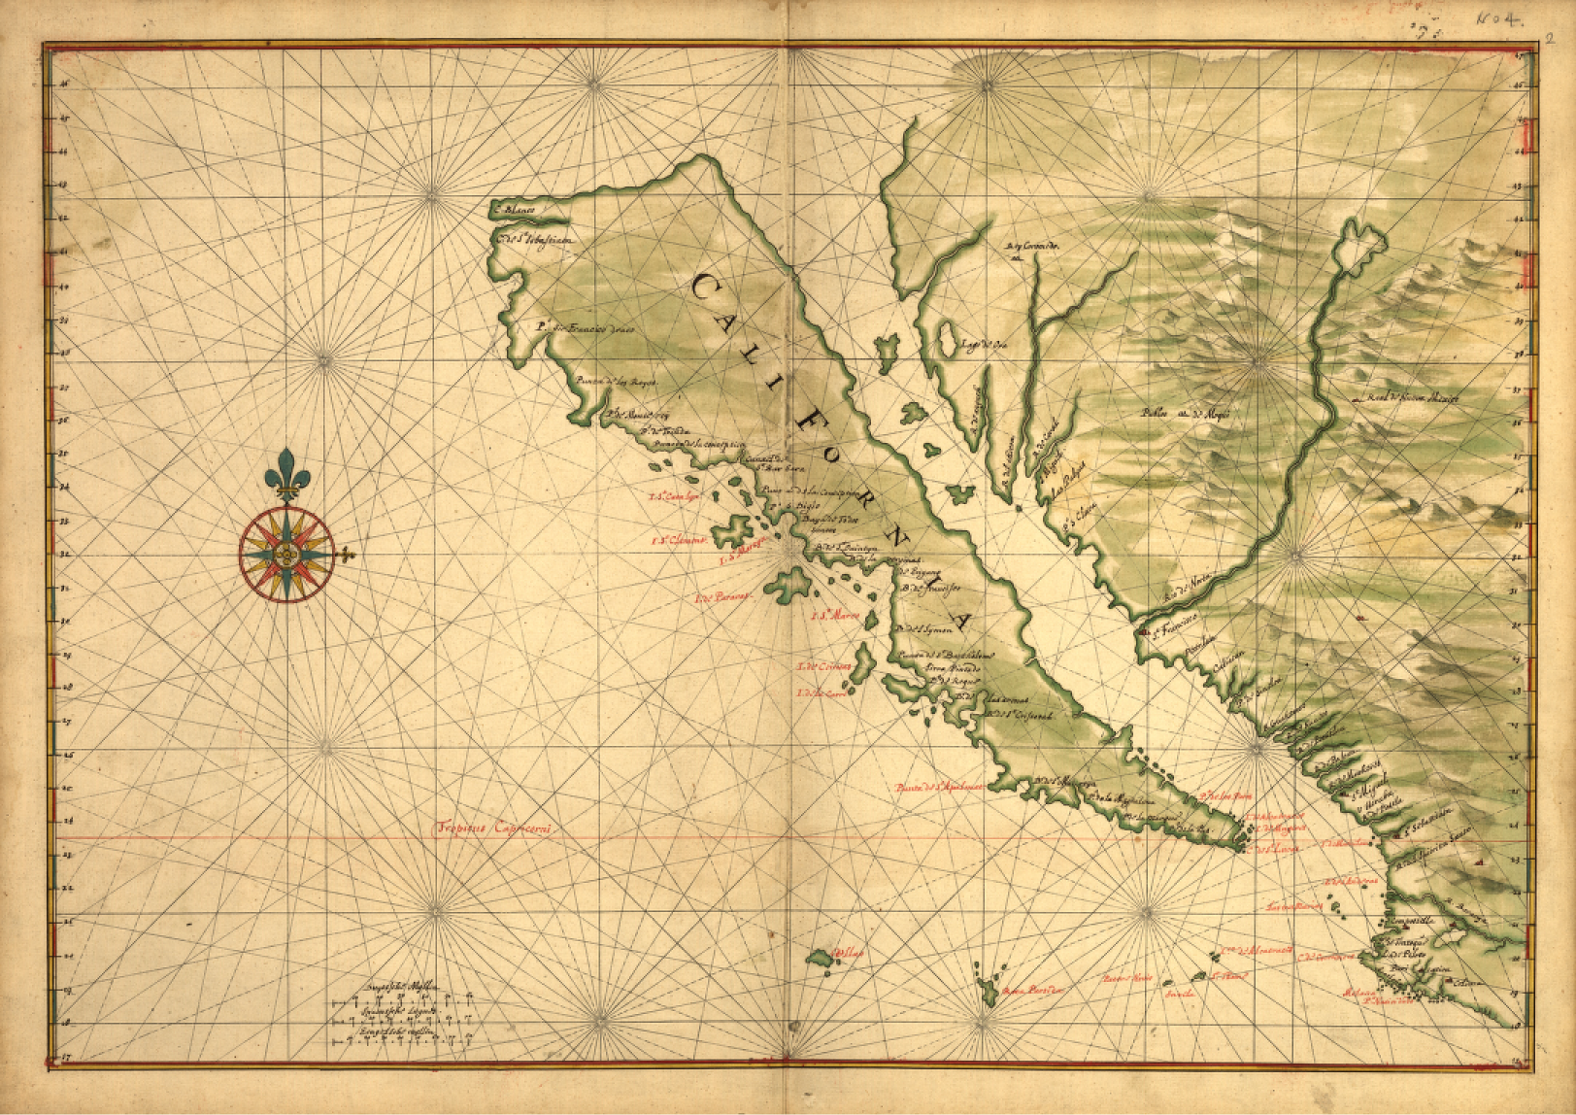
Figure 1. Johannes Vingboon’s 1639 map of California shown as an island (Public domain image reproduced from an original in the Collections of the United States Library of Congress Geography and Map Division.)

Delisle had access to privileged information about the peninsular geography of California which appeared on his map. Nolin duplicated this previously unknown and new geographical fact on the plagiarized version of his own map, and beat Delisle to publication. Delisle was able to document the privileged nature of his knowledge of California in the course of legal proceedings, and was therefore recognized as the true author of his map. Delisle documented other fictitious map artifacts and artistic features which he had included in his map and had been copied by Nolin (Pedley 2005, 107). These fictitious map artifacts, known to many as “cartographic traps”, have become a prevalent feature of printed and electronic maps, and have become a well known trigger mechanism to initiate a claim and to document plagiarism. This technique, used hundreds of years ago by cartographers such as Delisle, is still used today to identify maps and geographic data.
In general, a cartographic trap could be defined as “a specific form of copy right trap used on maps and cartographic documents to protect intellectual property. It takes the form of an identifiable artifact on the map which is promulgated through the map duplication process, thereby appearing in copies of the original map and derivative works based on the original. Cartographic traps often form the basis for identifying the source data for a derivative work, and are a relevant component in demonstrating copyright infringement” (Rice 2005). Great Britain’s Ordnance Survey refers to cartographic traps as “fingerprints” (Bale 2001). In the United States, they are sometimes known as “key traps”, “detectors”, “bunnies” (Stikeman 2000), and “trap streets” (Harvey 2000, 140). In Joanna Bales’ 2001 interview with a United Kingdom Ordnance Survey (OS) official, fingerprints were explained to include “extra stream tributaries, imaginary farm buildings, tiny kinks in rivers, exaggerated curves in roads, and missing apostrophes”. Bale describes the OS fingerprints as “deliberate and secret faults”, but another OS official claims the fingerprints “are not faults or errors, but subtle and secret ways of detecting plagiarism, rather like watermarks. Every map issuer does something similar” (ibid.). Vera Benson, Director of Cartography at American Map Corporation (AMC), echoed this sentiment, describing the use of cartographic traps as common in the cartographic industry (Harvey 2000, 140). Ken Atherton of the British Cartographic Association described traps as a natural progression in the process used to catch plagiarists, and noted that the use of cartographic traps “is thought to be widely practiced around world” (Bale 2001). Cartographic traps have been cited in a number of legal cases (Rice 2005, 22), yet they enjoy no innate copyright protection under current US law. They are simply a very effective way to quickly and unequivocally identify one’s own unique cartographic work.
Maps are now stored primarily in digital format. This research explores how the cartographic trap concept could be instituted with digital geospatial data. The presence of cartographic traps on printed maps is well documented, but there have been very few papers documenting their presence or effectiveness in geospatial databases. Lopez (2002) in his review of digital watermarking for geospatial datasets, notes that techniques for digital watermarking in raster datasets are well known (e.g., Bartlett 2001), but little work has been done with respect to vector datasets. Lopez states that it is “surprising that, despite the large costs associated with the collection and assembling of vector datasets, the ‘copy-protection-means’ has not been of interest to the GIS research community” (2002, 597).
Vector geospatial data (the subject of Lopez’s comments) are often stored as coordinates using double precision variables (64 bits). For coordinates stored in latitude and longitude, double precision variables can define position on globe to the micron level (Table 1). Many of the 64 bits are not used for defining position but are simply an artifact of computer programming, and can be exploited to carry information.

Decimal place | Approximate precision (latitude)
.0 | 11,124 meters (~11 Km)
.00 | 1,124 meters
.000 | 112 meters
.0000 | 11 meters
.00000 | 1 meter
.000000 | 11 centimeters
.0000000 | 1 cm
.00000000 | 1 mm
.000000000 | 0.1 mm
.0000000000 | 0.01 mm
.00000000000 | 1 micron
Table 1. Positional precision for latitude stored with a double precision variable (1° latitude ≈ 111,240 meters), Adapted from Rice (2005).

An experiment conducted by Rice (2005) looks at simple strategies for embedding an identifier in these double precision vector coordinate digits, and tests the degradation of the identifier through the repetitive cartographic projection transformations. Some cartographic projection transformations, such as the Albers Conic projection and the Sinusoidal projection, showed very stable behavior with regard to numerical stability and information loss. Other projection transformations, such as the Bonne projection and the Cassini projection, as well as compromise projections such as the Robinson projection, showed numerical instability and a level of information loss which would prohibit large-scale embedding of identifiers using simple techniques.
In order to elaborate on this approach, imagine a simple work situation where a team of users is tasked with creating, editing, and disseminating a simple geospatial vector dataset. In order to track this data as it is released and disseminated, a geospatial organization might want to embed an identifier that links to an internal database that tracks the data lineage, metadata, and licensing details. This identifier could take the form of a simple 4 digit number, such the PINs used for many private transactions. This 4 digit number could be embedded in a variety of different ways, but one of the easiest ways is to adopt a “least significant bits” approach described by Rice (2001) and subsequently by Thoen (2002a, 2002b) and Huber (2002), where an insignificant or superfluous portion of the coordinates of a vector geospatial dataset are changed in order to carry information. Rice (2005) demonstrates this approach using vector geospatial data stored as latitude and longitude coordinates with double precision variables. The lat/lon coordinates have been altered by removing the coordinate data in the sixth coordinate digit past the decimal and replacing it with a redundantly embedded PIN (Table 2).

Centroid ID | Longitude | Latitude
1 | -120.42802745000 | 47.37676795300
2 | -109.65253568700 | 47.03226545730
3 | -69.23428231410 | 45.38940234880
4 | -100.47075300400 | 47.44607357470
5 | -100.23528791500 | 44.43331714440
6 | -107.55308500900 | 42.99828575980
7 | -90.00619222760 | 44.63311288640
8 | -114.66186341600 | 44.38589347270
9 | -72.66065724220 | 44.07224758780
10 | -94.30594568430 | 46.31564556900
. . . | . . . | . . .
49 | -85.43860752940 | 44.33654744290
50 | -156.32981532100 | 20.24332599480
51 | -152.57130213300 | 64.31717279290
Table 2. Vector geospatial data with redundantly embedded PIN: 7523, Adapted from Rice (2005).

This altered data is then subjected to 50 forward and backward projection cycles in order to look at the degradation of the host (the vector coordinate data) and the signal (the embedded PIN). As would be expected, every major projection (as instantiated in ArcInfo Workstation 9.1’s projection utility) adds some numerical noise to the least significant digits of the coordinate digit. Some projections, including the Sinusoidal, Aitoff, and Albers Conic projections, fare very well, adding numerical noise to only the 3 least significant digits, equivalent to less than one tenth of a millimeter of ‘noise’ in the lat/lon coordinate digits. Other projections, including the Robinson, Bonne, and Cassini projections, added a substantial amount of noise to the coordinate digit, resulting on more than a meter of ‘noise’ being added to the coordinate digits. Table 3 shows the progression of the embedded PIN through 50 projection cycles for the Robinson projection. The PIN (‘7523’, embedded redundantly in the sixth decimal place) degrades immediately after the second projection cycle, becoming ‘8623’ (lat) & ‘8634’ (longitude), and further until it is unrecognizable after the 5th projection cycle. Figure 2 shows the same signal (PIN) degradation through 50 projection cycles for three popular cartographic projections. Clearly, the Sinusoidal and Winkel Tripel projections preserve the embedded signal very well through the course of the 50 projection cycles, while the Robinson projection shows near immediate degradation, which isn’t a surprise based on the differing methods for calculating coordinate values.

Iteration and PIN
1 |  | 2 |  | 3 |  | 4 |  | 5 |  | 10 |  | 20 |  | 30 |  | 40 |  | 50
x | y | x | y | x | y | X | y | x | y | x | y | x | y | X | y | x | y | x | Y
7 | 7 | 8 | 8 | 7 | 8 | 8 | 8 | 8 | 8 | 4 | 8 | 0 | 9 | 8 | 0 | 3 | 1 | 4 | 2
5 | 5 | 6 | 6 | 6 | 6 | 5 | 6 | 7 | 5 | 4 | 6 | 5 | 7 | 5 | 7 | 4 | 3 | 4 | 2
2 | 2 | 2 | 3 | 2 | 3 | 3 | 4 | 2 | 5 | 5 | 8 | 9 | 5 | 2 | 2 | 5 | 9 | 5 | 1
3 | 3 | 3 | 4 | 4 | 4 | 2 | 4 | 5 | 5 | 0 | 6 | 3 | 0 | 4 | 2 | 4 | 7 | 5 | 8
Table 3. Robinson projection, degradation of embedded PIN, Adapted from Rice (2005).

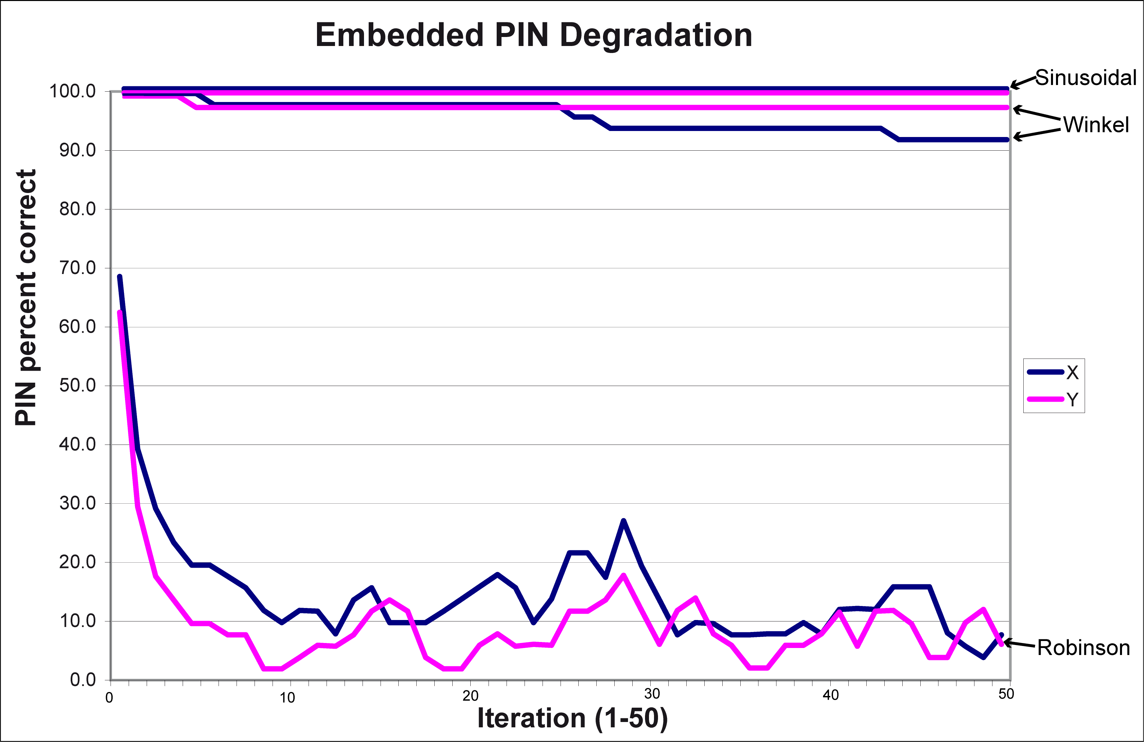
Figure 2. Embedded PIN degradation through 50 projection transformations associated with three popular cartographic projections, Adapted from Rice (2005).

While there are a wide variety of interesting results of this research (most of which are discussed in depth in Rice 2005), there are a few major issues that merit quick discussion. First, there is really no question that simple information can be embedded into raster and vector geospatial data, and that this information can be preserved through some reversible, lossy transformations. This result was suggested by Lopez (2002), and demonstrated by Rice (2001, 2002, 2003, 2005), Thoen (2002a, 2002b), Huber (2002), and others. Projection transformations are the most significant with respect to changes in coordinate digits and hence they have been the focus of this research. Although all projections result in some very minor changes to the coordinate digits (simply because of the machine calculations and associated errors), some projections fare better than others. Rice (2005) tested 15 different popular projection transformations in his dissertation research, and found most to have reasonable fidelity in preserving embedded information.
Formulas for generating X and Y coordinates involve different parameters, different calculations, etc. . . and therefore have different numerical properties with regard to ‘noise’ added to coordinate digits (Figure 2, Table 3, Rice 2005). Any significant routines for doing large scale digital watermarking, steganography, or information hiding with vector geospatial data will need to take into account the different numerical properties and behaviors of the X & Y components of a projection. Finally, embedded PINs or any embedded signal can be detected and removed by an attacker. In order to make this more difficult, embeded signals can be encrypted using simple alphabetic keyword ciphers (Rice 2001) in order to create a random appearance, thereby escaping analytical detection. This random appearance makes the PIN (or embedded signal) blend in with the other data, mimcing the realistic, believable appearance of traditional cartographic traps.
Embedded identifiers in vector geospatial data can function as ‘digital cartographic traps’, helping a user identify and track his/her geospatial data. This capability is could become important in tracking data lineage, verifying adherance to licensing agreements, and determining whether or not an archived geospatial dataset has been altered. Future research needs to be done on methods for embedding identifiers for surviving non-reversible vector transformations, as has been done with robust information hiding in images and raster data. Additionally, work needs to be done on looking closelly at the recommendations embodied in Lopez (2002) and Rice (2005) and figuring out where they fit (if at all) within more comprehensive geospatial data protection and licensing practices.

References

Bale, Joanna (2001), “Twists in the plot cost AA map cheats £20m”, London: The Times of London, Home News section, March 6, 2001.

Bartlett, Alan. (2001). “Digital Watermarking: The Unseen Advantage”, GeoInformatics: Magazine for Geo-IT Professionals, vol. 4, pp.6-9, June 2001.

Brown, Lloyd Arnold (1949). The Story of Maps. Boston: Little, Brown, and Company

Harvey, Miles (2000). The Island of Lost Maps: A True Story of Cartographic Crime. New York: Random House.

Huber, William A. (2002). “GIS & Steganography, Part 3” Directions Magazine, April 18, 2002. http://www.directionsmag.com/article.php?article_id=195 [last accessed, October 2005]

Lopez, Carlos. (2002). “Watermarking of digital geospatial datasets: a review of technical, legal, and copyright issues.” International Journal of Geographical Information Science, vol. 16, no. 6, pp. 589-607.

Pedley, Mary Sponberg (2005). The Commerce of Cartography: Making and Marketing Maps in Eighteenth-Century France and England. Chicago: The University of Chicago Press.

Rice, Matthew T. (2001). “Strategies for Robust Digital Cartographic Steganography”, In Proceedings, The 20th International Cartographic Conference, ICC2001, Beijing, China, August 6-10th, 2001, vol. 2, pp. 1156-1164.

Rice, Matthew T. (2002) "Digital Cartographic Steganography and Self-Describing Maps" The Second International Conference on Geographic Information Science, Boulder Colorado, USA, September 25-28, 2002, pp. 149-152.

Rice, Matthew T., Keith C. Clarke, and Sarah Battersby. (2003) "Information Hiding Approaches for Self-describing Cartographic Data." Proceedings, The 21st International Cartographic Conference, ICC2003, Durban, South Africa, August 10-16th, 2003, pp. 1927-1935.

Rice, Matthew T. (2005). Intellectual Property Control for Maps and Geographic Data. Doctoral Dissertation, chair: Dr. Michael F. Goodchild. Santa Barbara, California: University of California, Department of Geography.

Thoen, Bill. (2002a). “GIS & Steganography, Part 1” Directions Magazine, April 9, 2002. http://www.directionsmag.com/article.php?article_id=189 [last accessed: October 5, 2005]

Thoen, Bill. (2002b). “GIS & Steganography, Part 2” Directions Magazine, April 16, 2002. http://www.directionsmag.com/article.php?article_id=192 [last accessed: October 5, 2005]

